**Sharing team knowledge using Project wikis Activity # 8**

**20K-0409 Mukand**

**Creating project**

**Task 1:**

**Task 2:**

**Img is displaying**

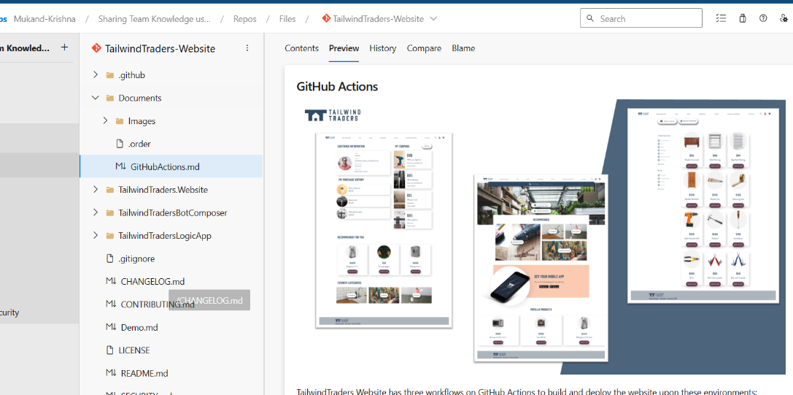

**Exercise 2: Create and manage a project wiki.**

**Task 1:**

**7 - 14.**

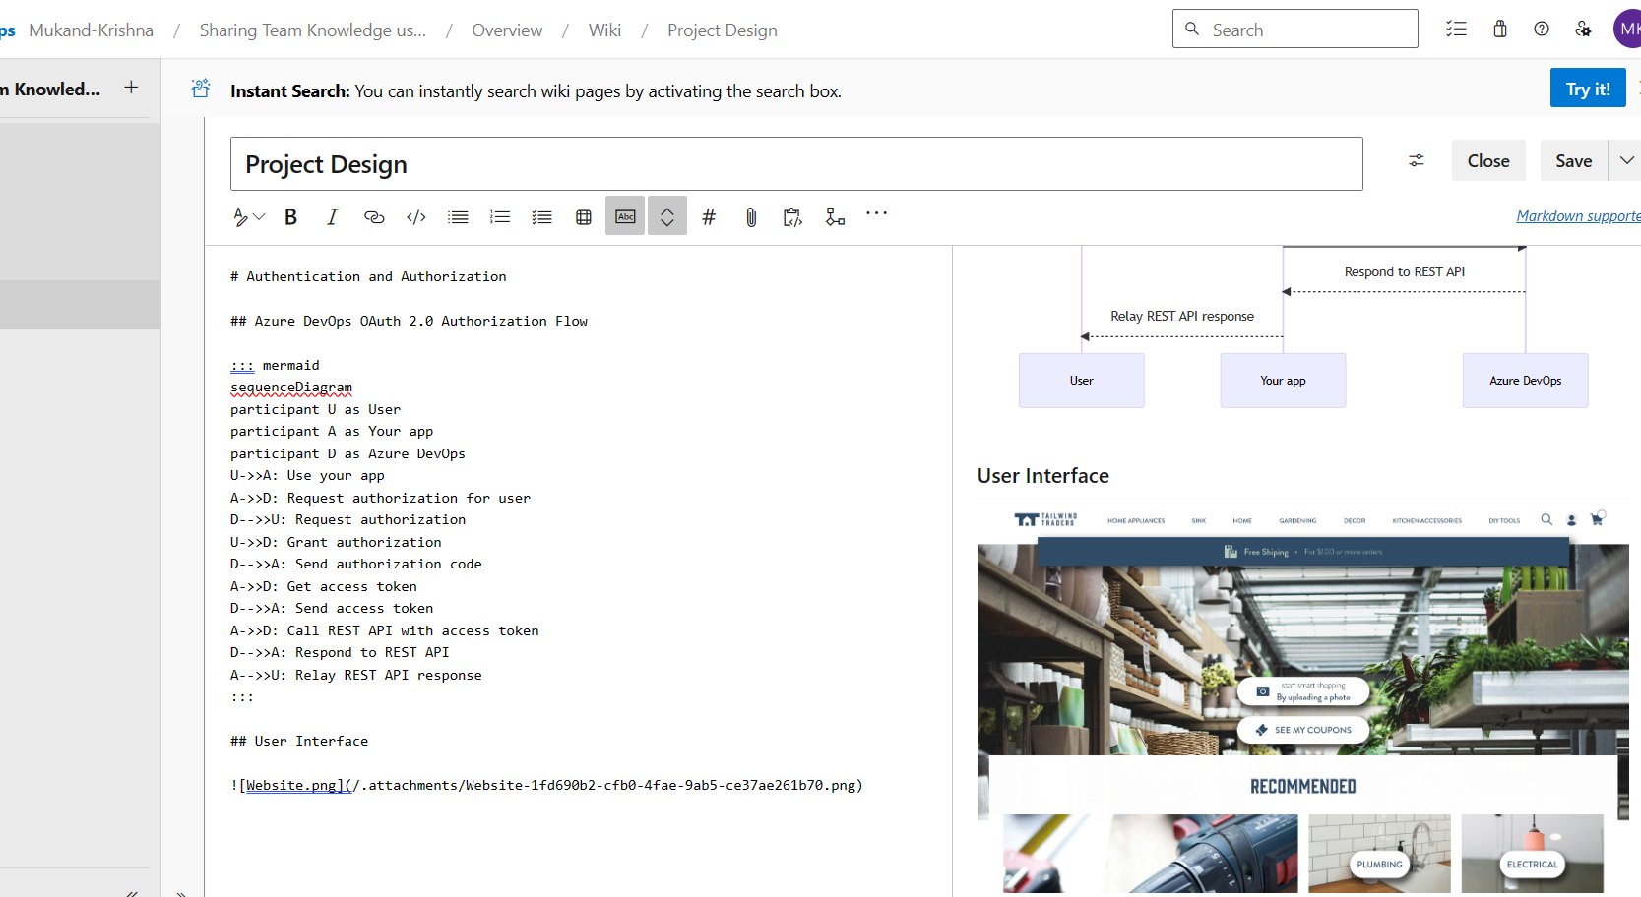

**Task 2: Manage a project wiki**



